**Finding Lane Lines on the Road**

**Write up**

July 10th, 2021 Kenta Kumazaki

**1. Purpose**

The goals / steps of this project are the following:

* Make a pipeline that finds lane lines on the road. (figure1)
* Reflect on my work in a written report.

**2. Submission**

**(1) GitHub**

<https://github.com/kkumazaki/Self-Drivig-Car_Project1_Finding-Lane-Lines.git>

**(2) Directory**

<folder: main>

* **Writeup_of_Lesson3.pdf**: This file
* **P1.jpynb**: Pipeline

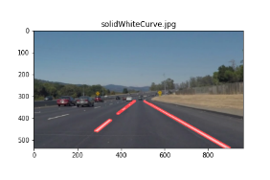<folder: test_images_output>

<folder: without_average_extrapolate>

**“image file name”_low_”tuning value”_high_”tuning value”.png**:   
Lane lines without average or extrapolate.

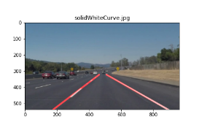 <folder: with_average_extrapolate>

**final_“image file name”_low_”tuning value”_high_”tuning value”.png**:   
Lane lines with average and extrapolate.

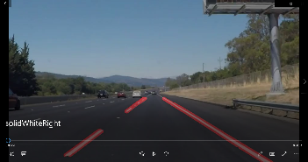<folder: test_video_output>

<folder: without_average_extrapolate>

**“video file name”.mp4**:   
Lane lines without average or extrapolate.

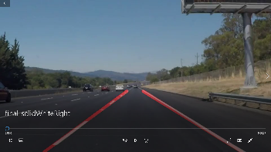 <folder: with_average_extrapolate>

**final_“video file name”.mp4**:   
Lane lines with average and extrapolate.

**3. Reflection**

**(1)Description of my pipeline**

My pipeline consisted of 7 steps.

First, I converted the images to grayscale.

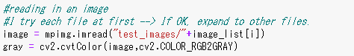

Second, I applied Gaussian smoothing to decrease noise.

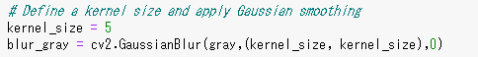

Third, I got edges from the images by using Canny Edges.

I tried 3 sets of parameters, and I chose 1st one after checking pictures and movies.  
I will explain why I chose it later.

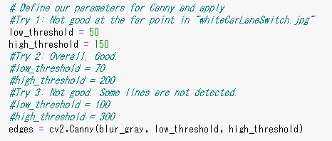

Forth, I created a masked area whose shape is four sided polygon.

I tuned that area in Lesson 3.

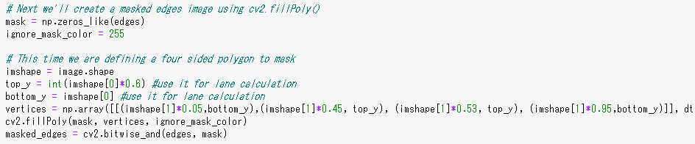

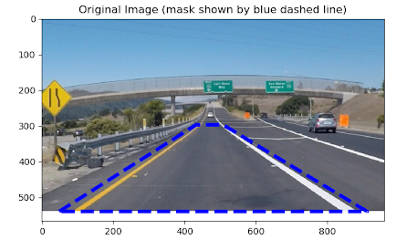

bottom_y

top_y

Fifth, I applied Hough transform.

I tuned the parameters in Lesson 3.

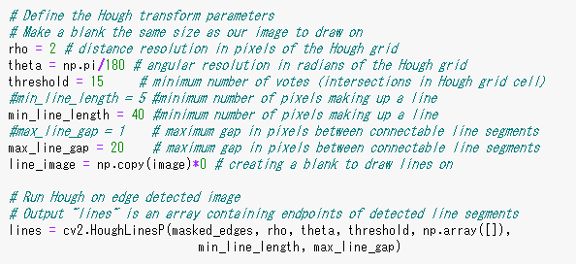

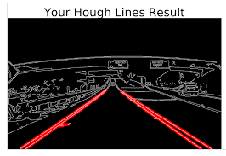

Sixth, I outputted the detected lane lines. I separated 2 modes here.

[Mode1] Just show the Hough Lines results.

The results of this are in the folder “without_average_extrapolate”.

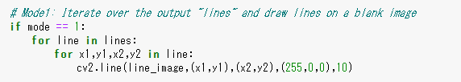

[Mode2] Extrapolate every Hough Line, then separate them into left side and right side and calculate  
 the average in each side.

The results of this are in the folder “with_average_extrapolate”.

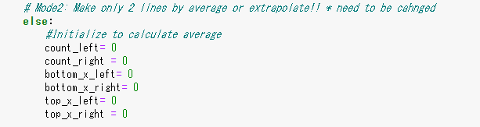

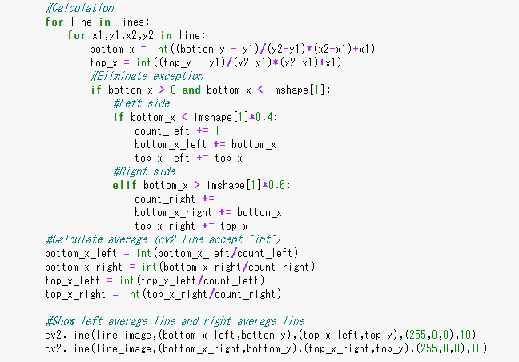

x

x

Calculate average positions of “x”.

Positions of “y” are fixed to “top_y”   
and “bottom_y”, so no need to calculate “y” here.

Separate left side and right side.  
I don’t count the lines whose bottom  
position is around the center.

Calculate extrapolate line.

Only inside image size.

y

y

Left side

Right side

Right side

Left side

top_x_right, top_y

top_x_left, top_y

bottom_x_right, bottom_y

bottom_x_left, bottom_y

Finally seventh, I drew the lines of the edge image.  
I will show the results in the next section.

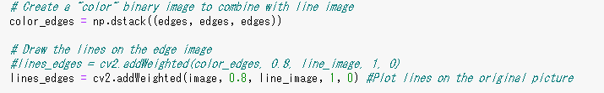

**(2) Result of my pipeline**

I tuned the parameters of Canny Edges.



When I checked the figures in “test_images” folder, second set (low: 70, high: 200) looked better than 1st set  
(low: 50, high: 150) because there were unwanted lines. Second set also looked better than 3rd set (low: 100, high: 300) because there were some lane detection missing.

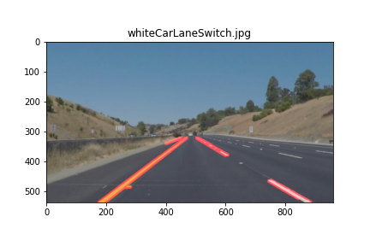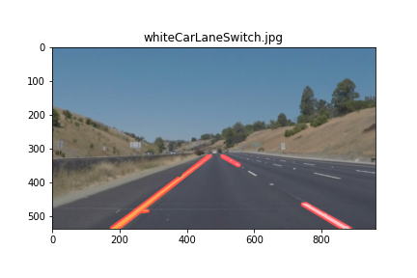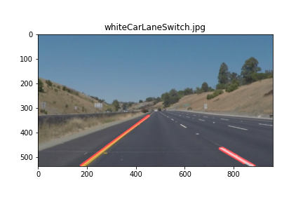

Looks good

Detection missing

Unwanted line

3rd set (low: 100, high: 300)

2nd set (low: 70, high: 200)

1st set (low: 50, high: 150)

However, when I ran the movie file (with average and extrapolate), the lane lines disappeared often.  
It means that the thresholds of 2nd set (low: 70, high: 200) were too high to detect enough lane lines.

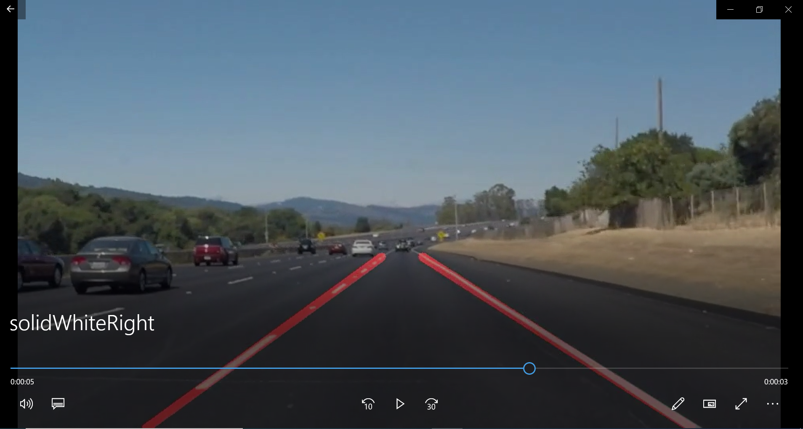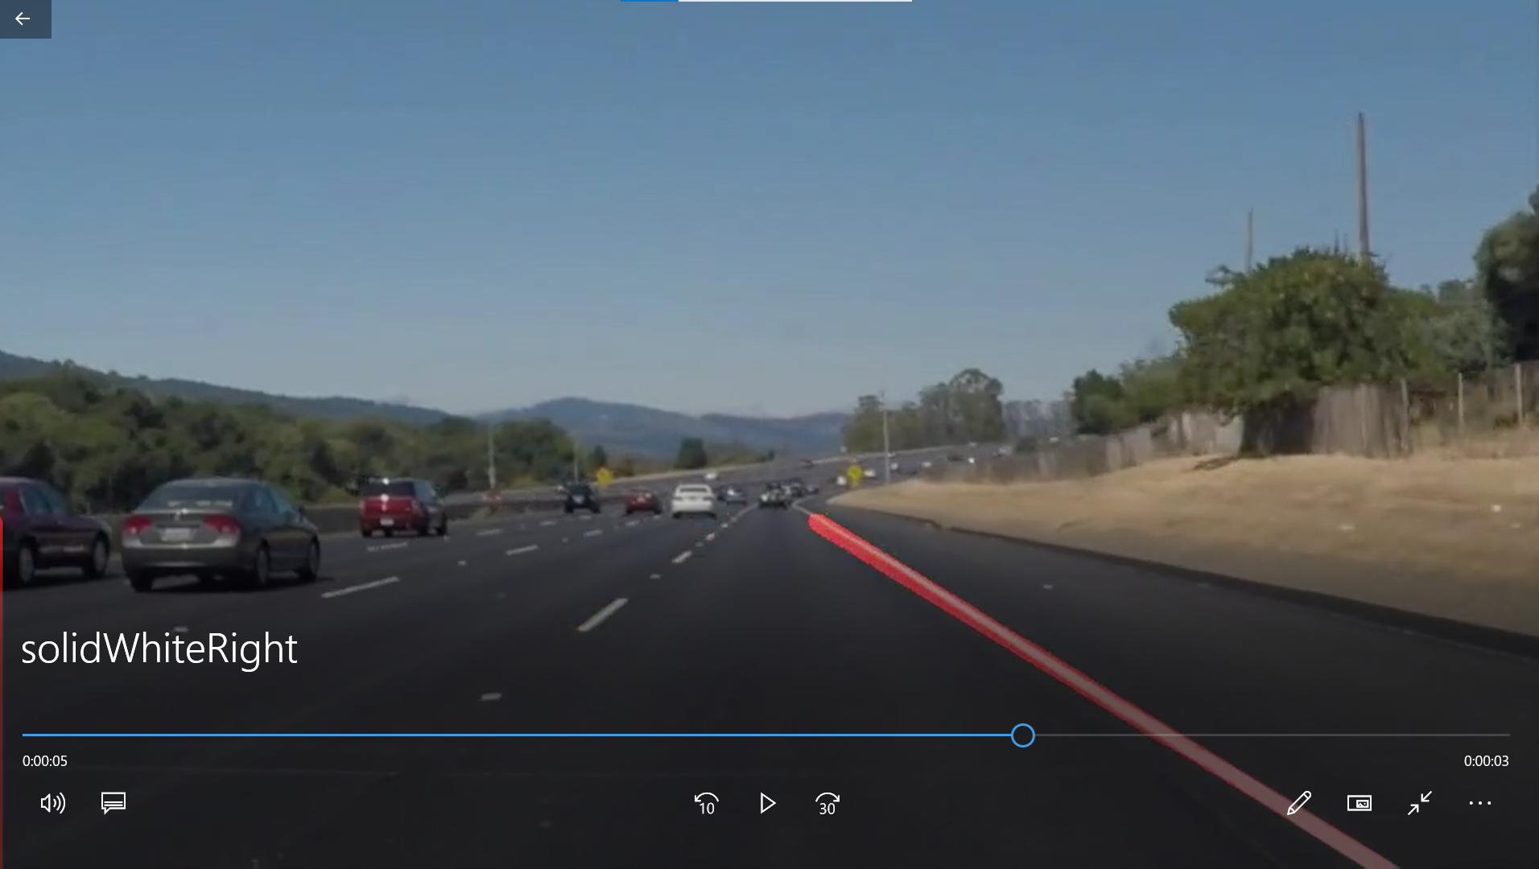

Detection missing

I checked the other figures in “test_images” folder with 1st set, and other resulting figures looked good.  
I thought that I can decrease the effect of unwanted lines by extrapolate and average, so I finally chose the tuning parameter as 1st set (low: 50, high: 150).

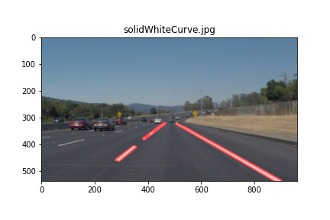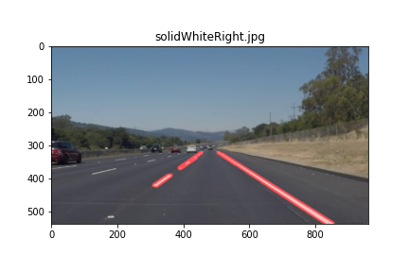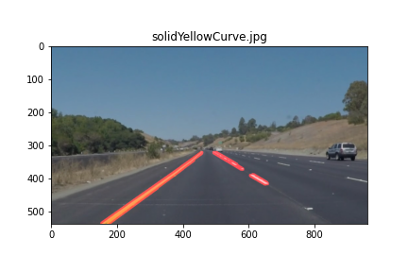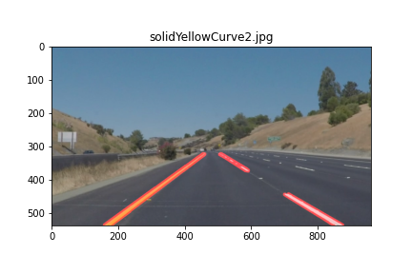

Other resulting figures with tuning parameters: 1st set (low: 50, high: 150)  
*: They are saved in the folder “without_average_extrapolate”, file names are **“file name”_low_50_high_150.png**

The following figures are the results of extrapolate and average. As I assumed, the unwanted line in the figure “whiteCarLaneSwitch.jpg” disappeared after extrapolate and average.

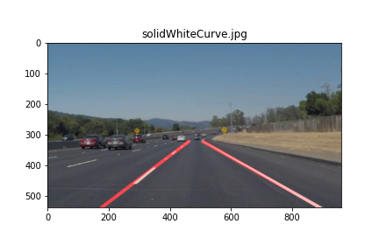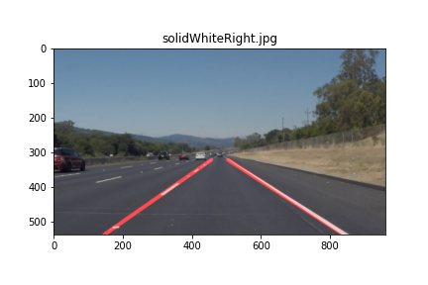

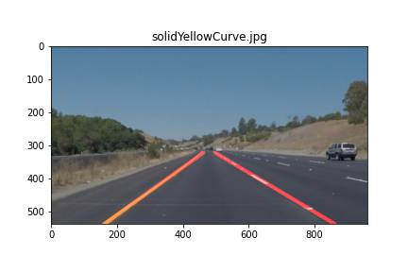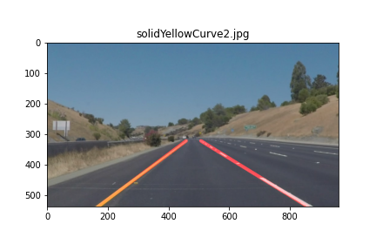

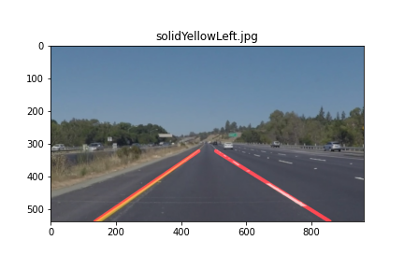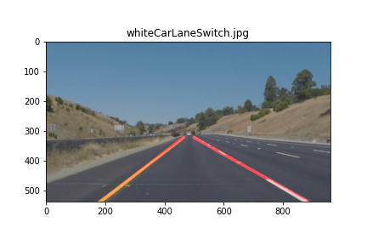

Final resulting figures with tuning parameters: 1st set (low: 50, high: 150)  
*: They are saved in the folder “with_average_extrapolate”, file names are **final_“file name”_low_50_high_150.png**

No unwanted line

I ran my pipeline in the 2 video files, solidWhiteRight.mp4 and solidYellowLeft.mp4.

I checked my pipeline worked well with these sample video files.

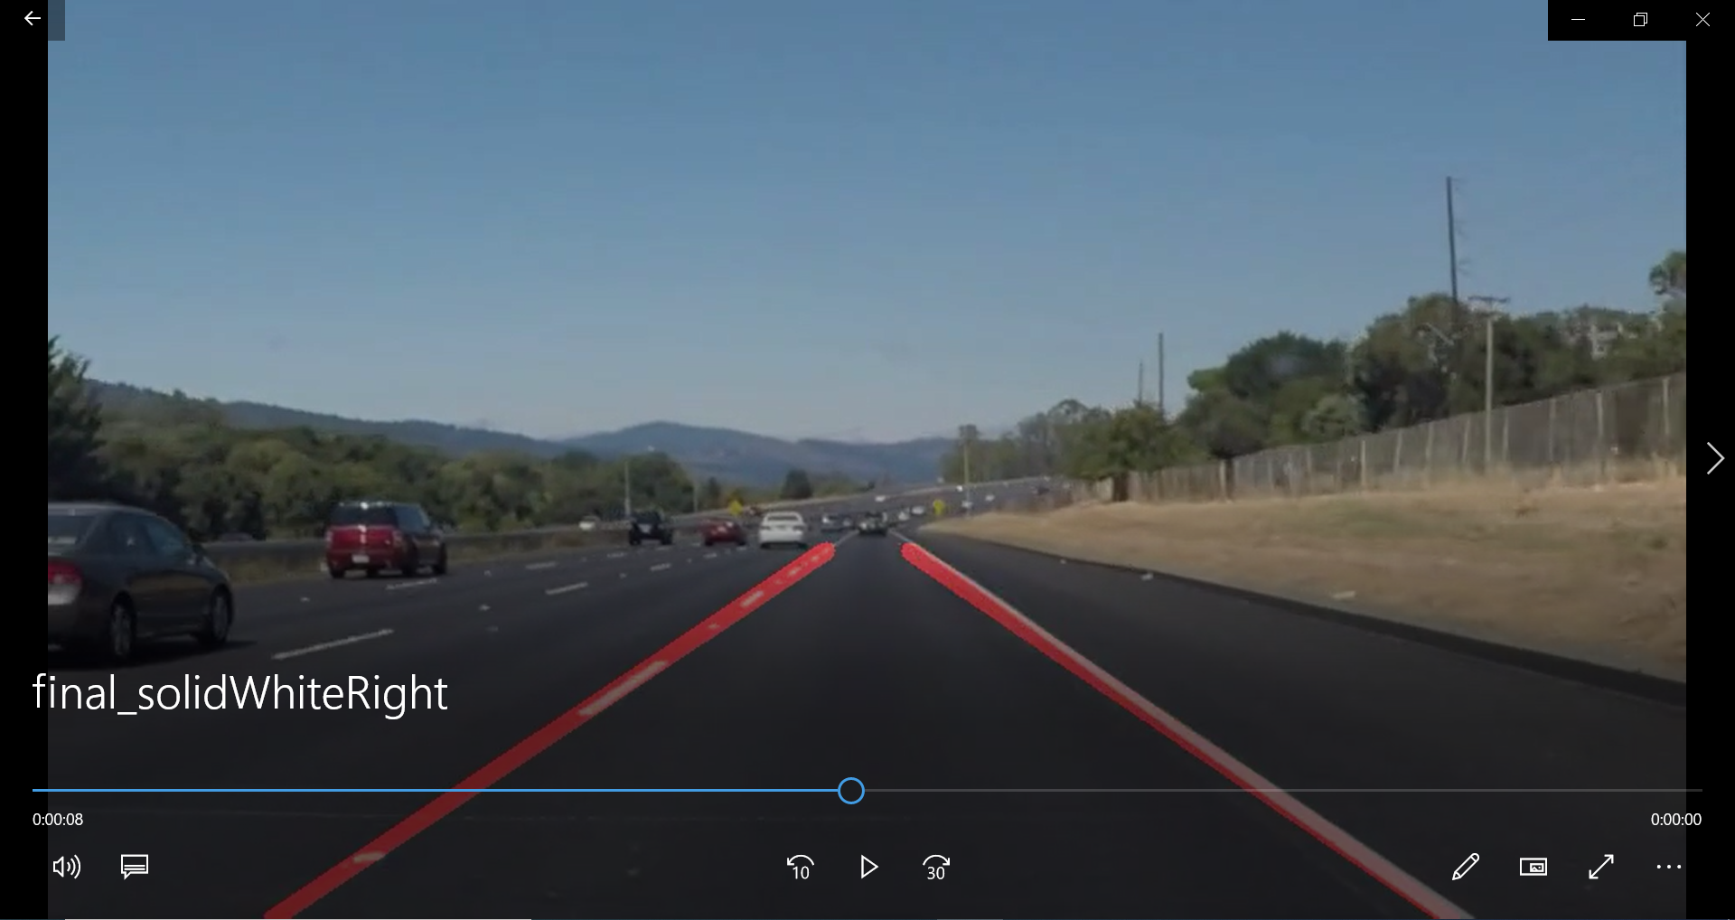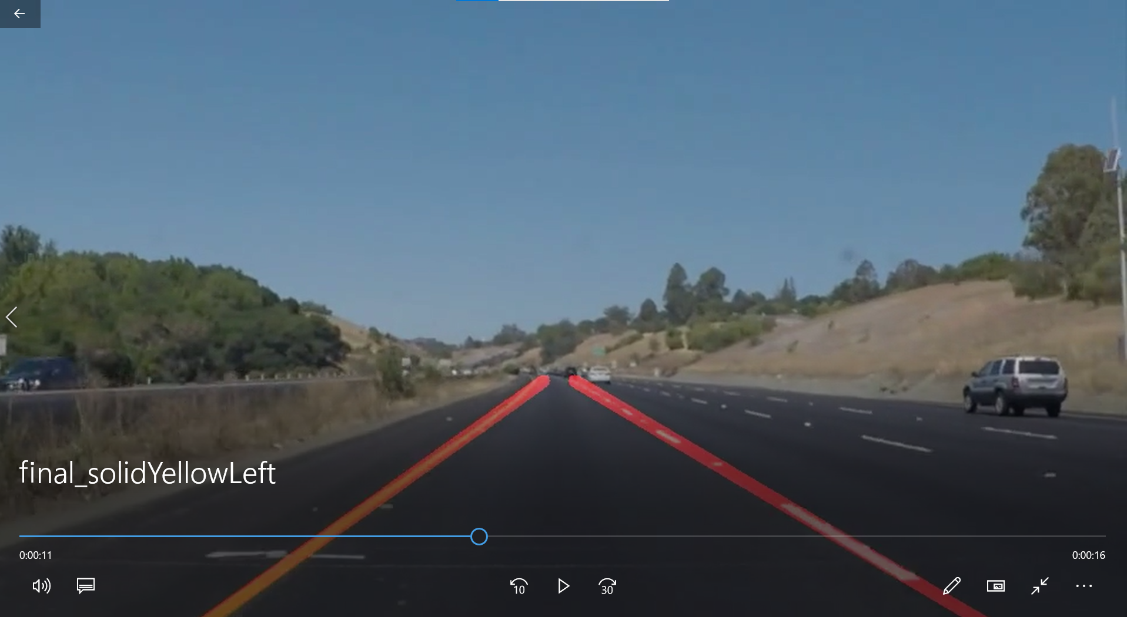

Final resulting videos with tuning parameters: 1st set (low: 50, high: 150)  
*: They are saved in the folder “with_average_extrapolate”, file names are **final_“file name”.mp4**

Final resulting videos with tuning parameters: 1st set (low: 50, high: 150)  
*: They are saved in the folder “with_average_extrapolate”, file names are **final_“file name”.mp4**

**(3) Identification of potential shortcomings with my current pipeline**

I ran my pipeline with “challenge.mp4”. I found 3 potential shortcomings with my current pipeline as bellow:

**(i) Robustness against shades**

The lane line in the left side was detached nearby the tree. I checked Hough Edges in this scene, and there are a lot of unwanted lines which match with tree shades. It affected the result of averaged line in the left side.

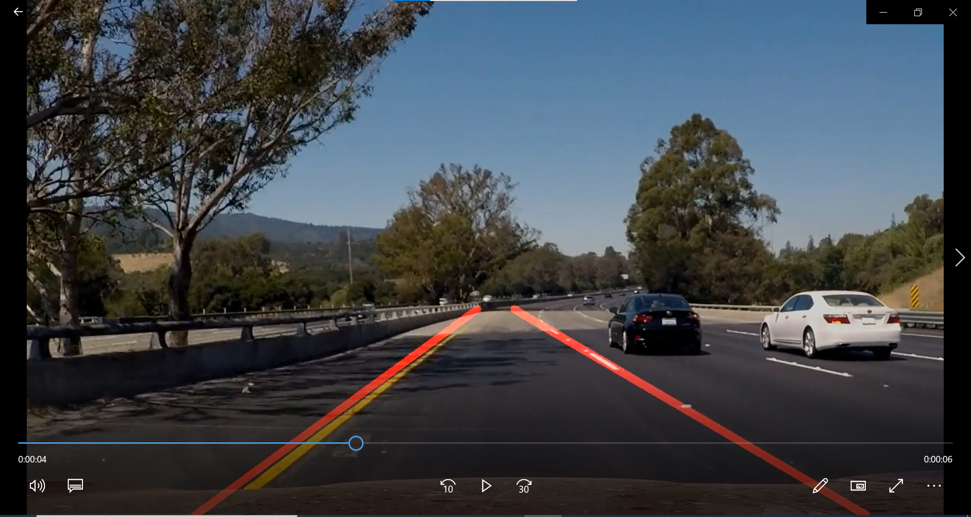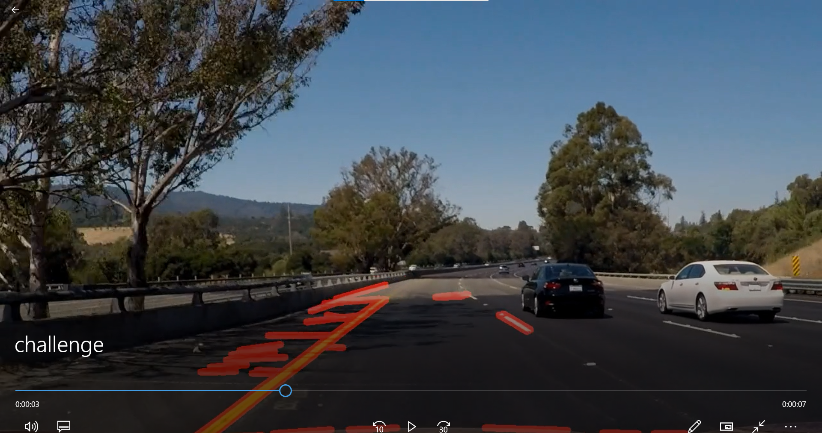

Resulting videos with challenge.mp4 (no extrapolate, average)

*: File names is **challenge.mp4**

Final resulting videos with challenge.mp4

*: File names is **final_challenge.mp4**

**(ii) Robustness against curves**

The lane line in the left side was detached in a curve. I checked Hough Edges in this scene, and there was an unwanted edge which matches with the outside lane. It affected the result of averaged line in the left side.  
And also, another reason is that I plotted straight line but real lane line is a curve.

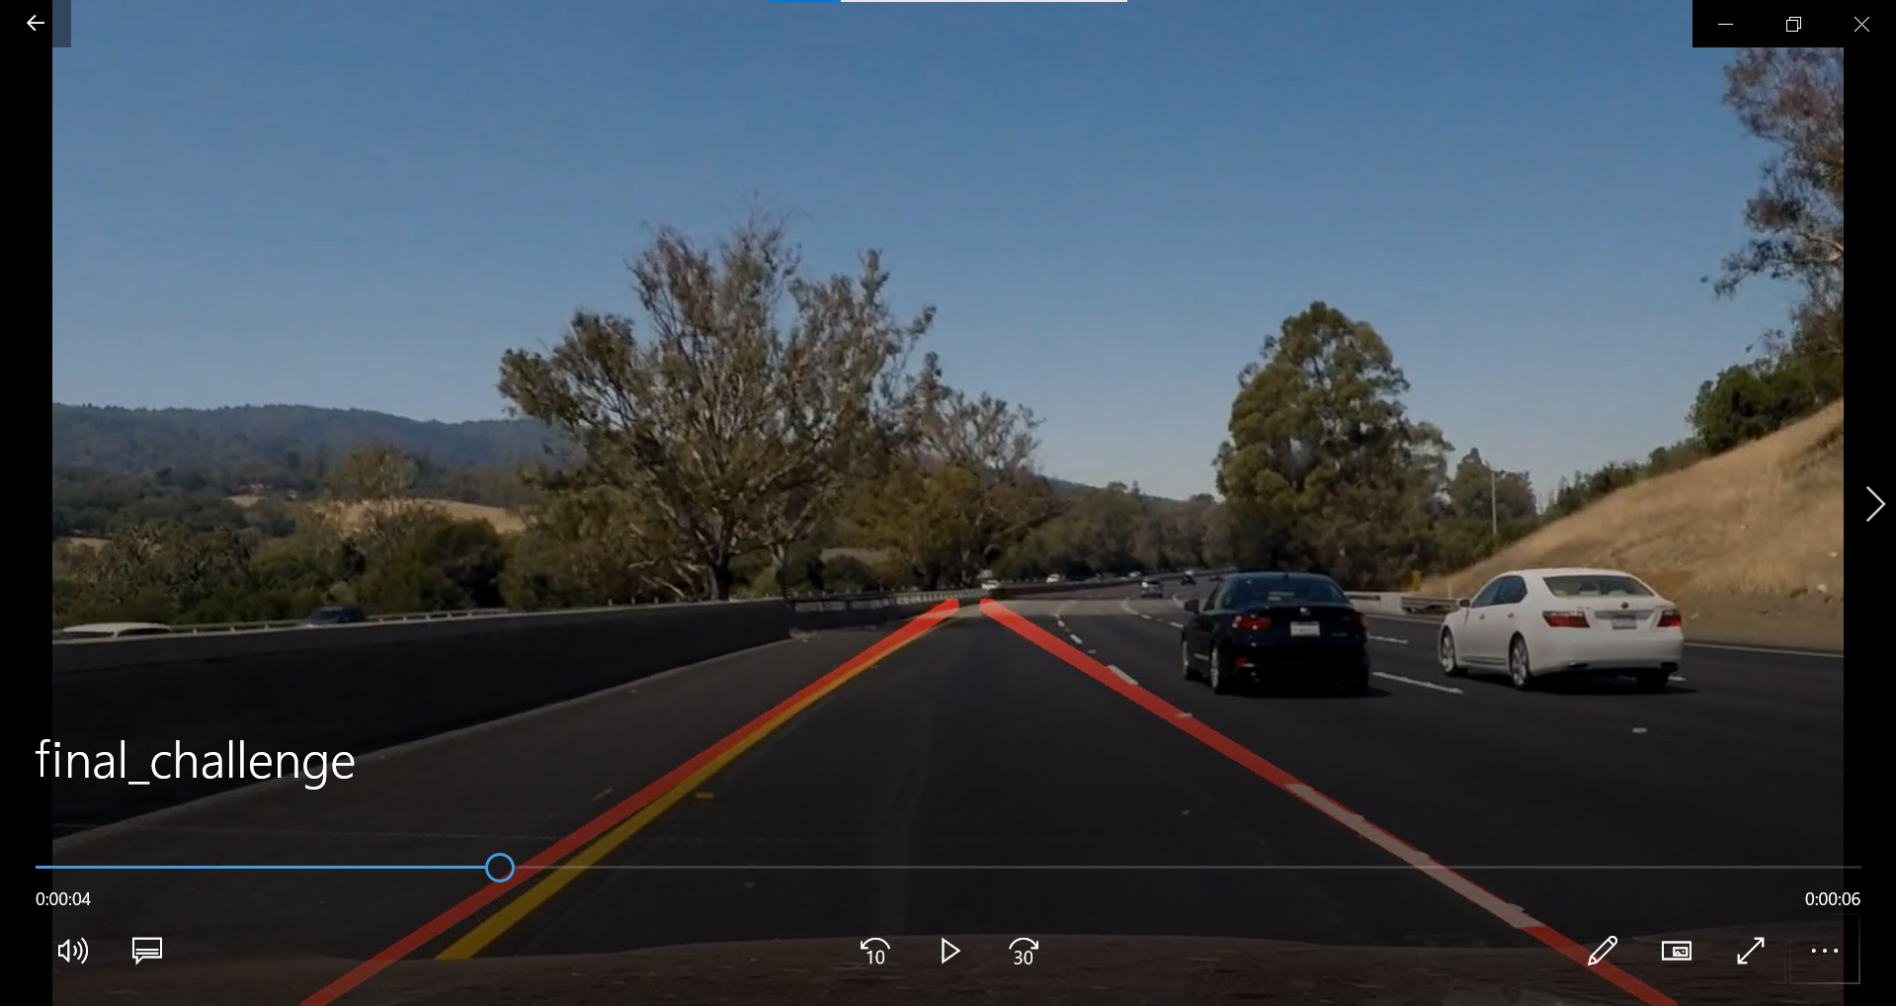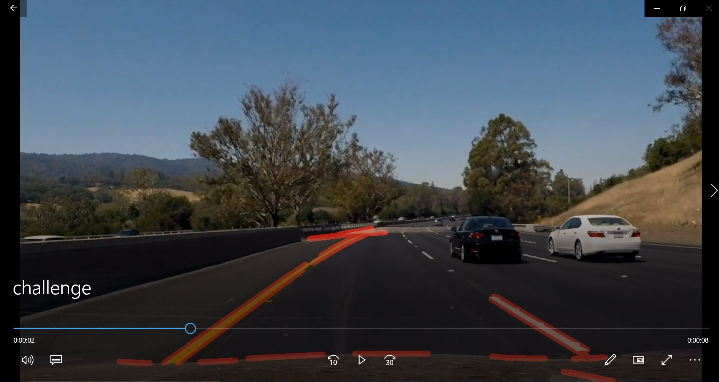

Resulting videos with challenge.mp4 (no extrapolate, average)

*: File names is **challenge.mp4**

Final resulting videos with challenge.mp4

*: File names is **final_challenge.mp4**

**(iii) Robustness against road color**

The lane line in the left side disappeared when the road color was changed. Yellow lane line was difficult to detect because the road color was similar to yellow.

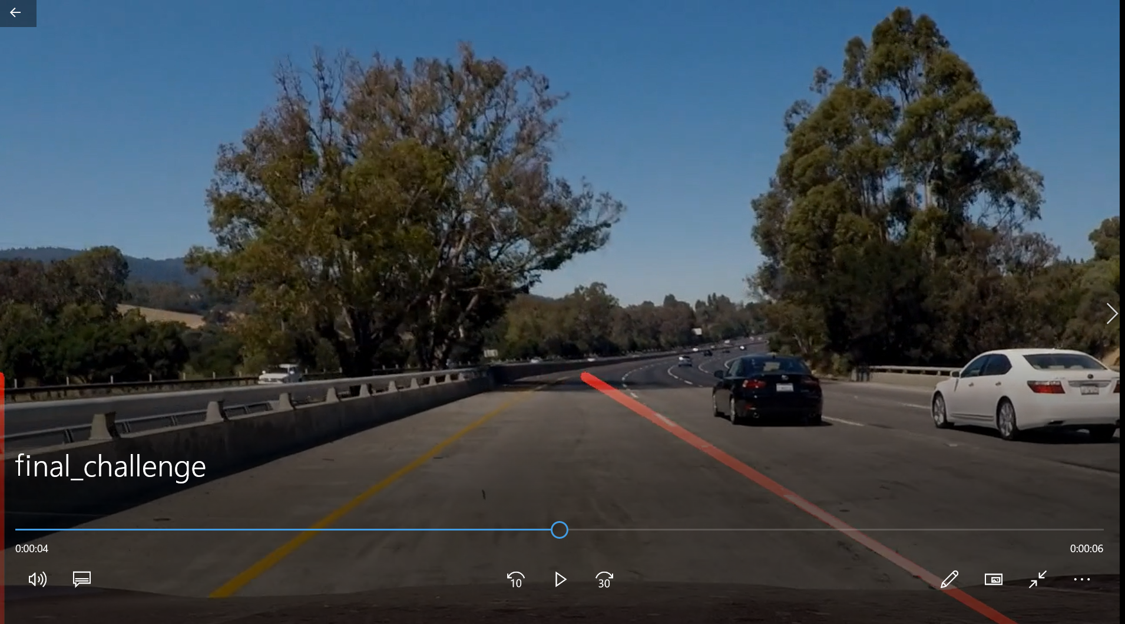

Final resulting videos with challenge.mp4

*: File names is **final_challenge.mp4**

**(4) Suggestion of possible improvements to my pipeline**

**(i) Robustness against shades**

I simply calculated average of Hough Lines in page 4.  
Usually real lane lines are longer than unwanted lines, so I think the robustness will be improved if I set bigger weights on the longer Hough lines when I calculate the average.

bottom_x_left, bottom_y

top_x_left, top_y

top_x_right, top_y

bottom_x_right, bottom_y

**(ii) Robustness against curves**

I’d better not to use straight line but use approximate curve by python function “polyfit” in numpy library because Hough lines match well with the real road. And also, we have to care about unwanted edge which matches with the outside lane same as (i). (Bellow figure is the same one as the previous page)



**(iii) Robustness against road color**

When I changed the parameters of Canny Edge to low=20, high=60, I was able to detect the left lane as below left movie. However, there are more unwanted Hough Lines on the usual road color area as below right movie. I think it’s better to change the Canny Edge parameters dynamically according to the brightness of the current road color.

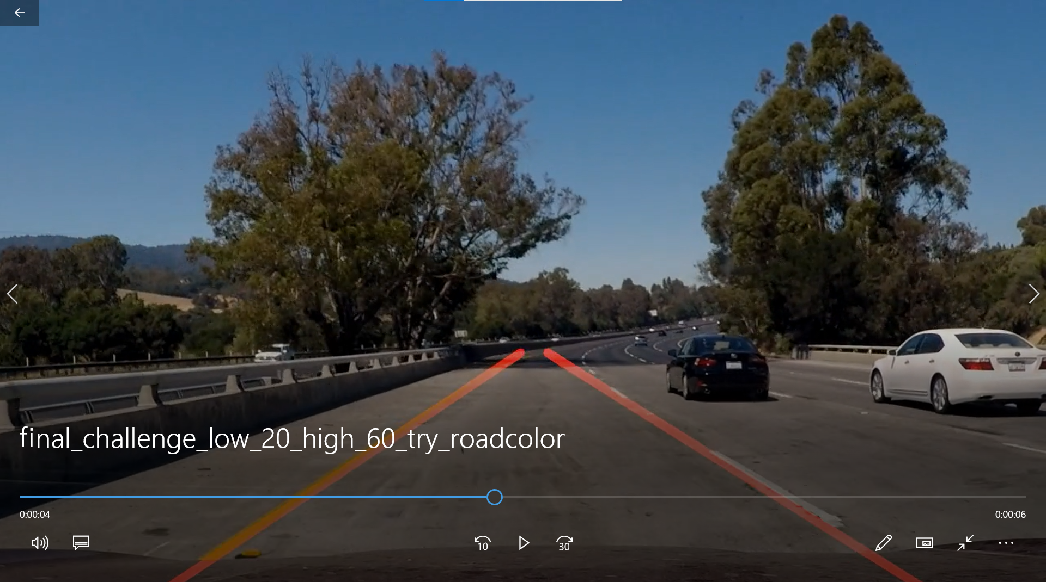 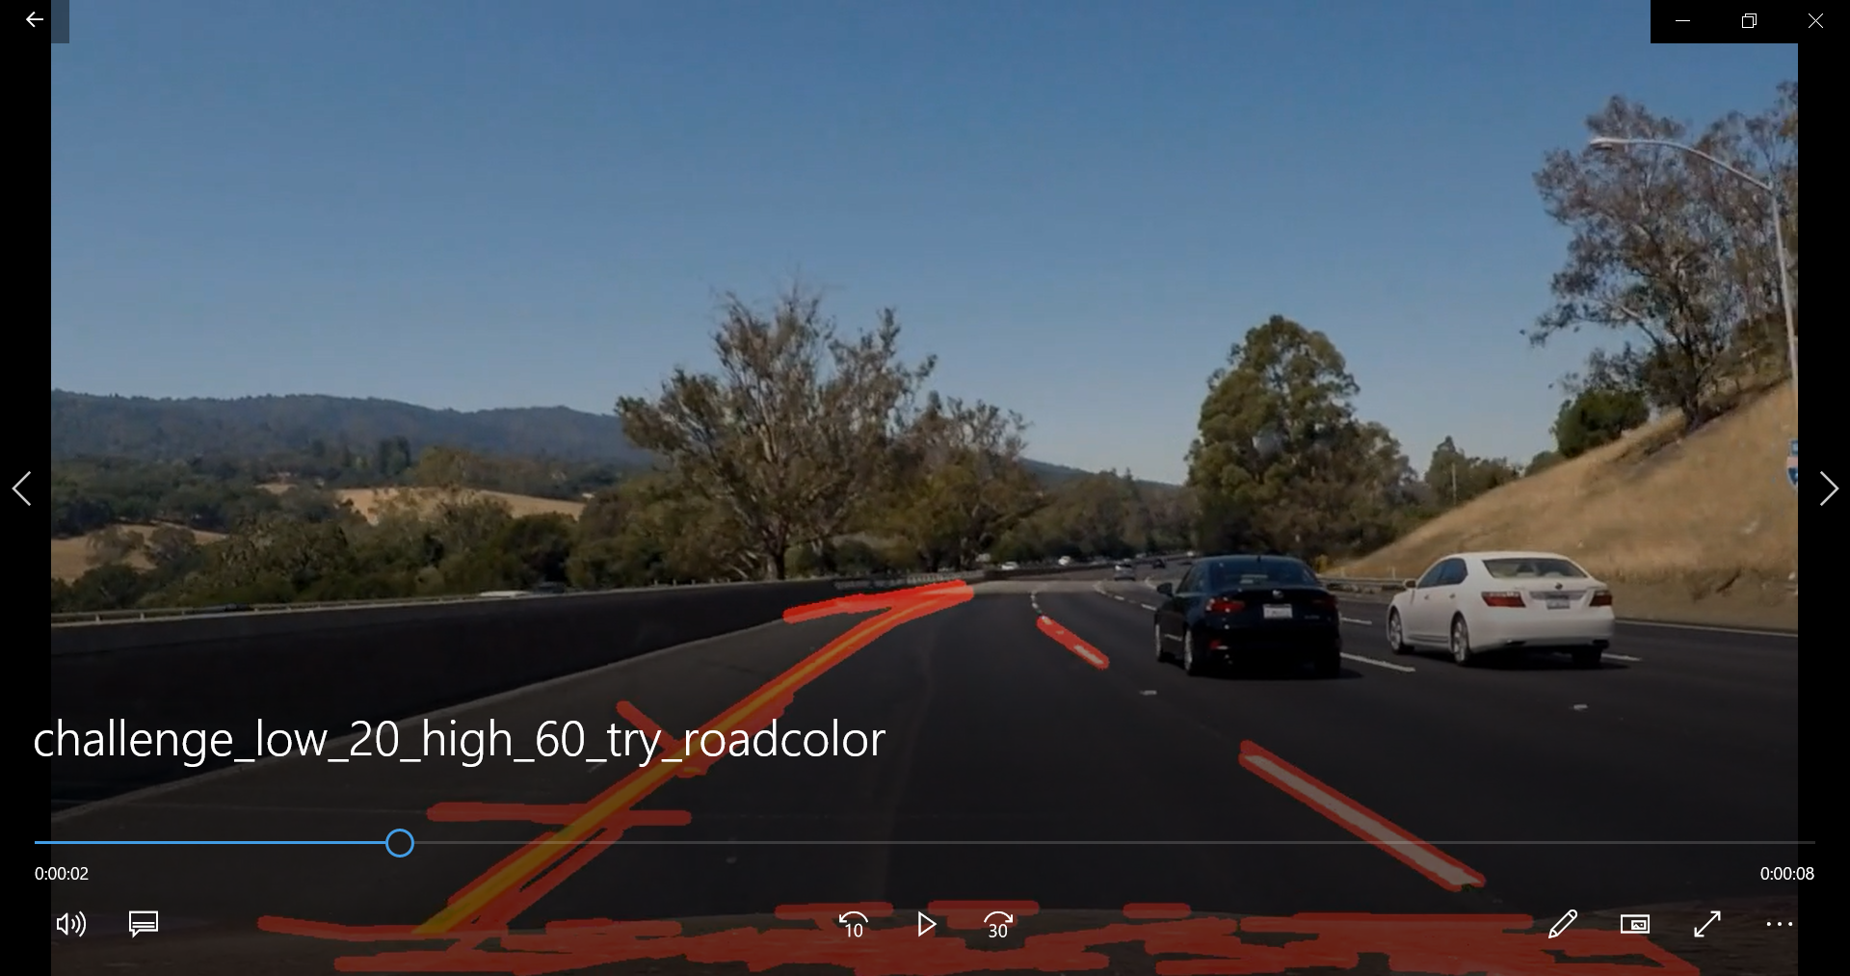

Parameter change video with challenge.mp4

*: File names is **challenge_low_20_high_60_try_roadcolor.mp4**

Parameter change video with challenge.mp4

*: File names is **final_challenge_low_20_high_60_try_roadcolor.mp4**